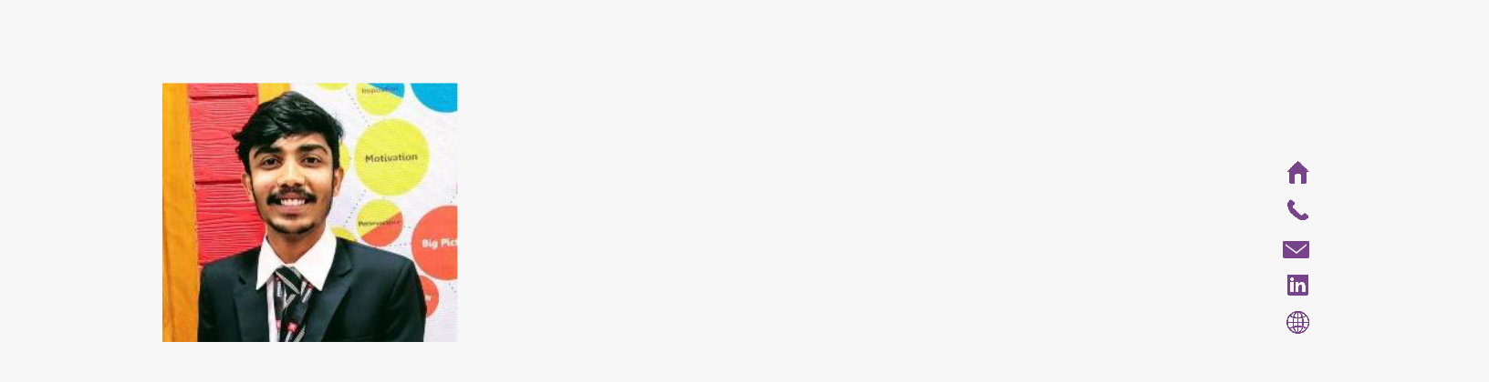
AbhishAbhishek Sonnakula
ABHISHEK | Kachiguda , Hyderabad
SONNAKULA | 9553911455
SONNAKULA | Sonnakulaabhishek98@gmail.com
‘BLAZING DEVELOPER’
https://abhisheksonnakula.github.io


OBJECTIVE

I am always up for new challenges. I am well organized and always plan ahead to make sure I manage my time, and to make use of my interpersonal skills to achieve the goals of a company that focuses on customer satisfaction and customer experience.


EDUCATION

B-Tech (JNTUH) | Hyderabad Institute of Technology and Management

2016 – 2020 (Pursuing)
Stream – Computer Science
Percentage – 60%

10+2 (Intermediate) | Narayan Junior College

2014 – 2016
Stream – Mathematics, Physics & Chemistry

Percentage – 72%

High School (SSC) | Brilliant Grammar High School

Stream – State Syllabus

Percentage – 80%


INTERNSHIPS
React Native & Web Developer | XLENZ HYD

(ONGOING)

Web Development | ROMP HYD

2019

Full-Stack Developer | ESIC Hospitals HYD

2018

Student Coordinator | U Decipher HYD

2018


PROJECTS

Doctors Duty Roster| ESIC Hospitals HYD

Technologies: NodeJS, MongoDB, Bootstrap.

This project helped the doctors of ESIC hospital to build their daily duty schedule and push it to the domain where the Higher Authorities of the hospital will cross check and approve it. This will help the patients to check the availability of doctors for particular hour or day.

Patients Referral System| ESIC Hospitals HYD

Technologies: NodeJS, MongoDB, Bootstrap.

This website helps the doctors to refer the registered patient to another hospital if the required treatment is not available in the particular hospital. As it is a government hospital there are several stages for approval of the referral, so it becomes easy for the patients to track their referral slip and proceed for the treatment.

Personal Assistant Bot| ATMECS CHAT BOT CHALLENGE HYD

Technologies: API.AI, Facebook API.

This is an advanced AI bot to perform task for user as its virtual personal assistant. Example: book a cab, book a movie ticket (performs all the tasks instantly reducing the burden for downloading additional apps for performing the task)

Sortify (web-extension)| HACKSPRINT MOZILLA JNTU-HYD

Technologies: JavaScript.

This a web extension used to suggest user preferred websites on his mood and priorities.

Madadgaar | EPICS HITAM
Technologies: NodeJS, MongoDB, Bootstrap, ReactJs.

This is an online portal, namely Madadgaar, exclusively for the networking of NGOs and philanthropists.

This portal includes the actual amenities or needs which have to be pertinently attended to by the NGOs.

SRG SERVICES| SRI GANA ENTERPRISES
Technologies: NodeJS, MongoDB, Bootstrap.

This websites help the company in providing utility & cab services in collecting payments through payment gateway. This serves as both B2B & B2C sectors.

CONFERENCES

International Conference on Transformation of Engineering Education
NOIDA

2018

International Conference on Transformation of Engineering Education
CHANDIGARH

2019

2

SKILLS

Technologies |  | Programing Languages
 | NodeJs |  |  | Python  Java
 | MongoDB  React Native  Git |  |  | JavaScript
   | Cordova | Tools
   | Express |  | GitHub
   | Bootstrap |  | Linux
 |  |  |  | Java
 |  |  |  |  | Adobe Photoshop
Operating Systems |  |  |  |  | API.ai
 | Ubuntu |  |  |  | Amazon Web services
 | Windows |  |  |  | Visual Studio Code

HACKATHONS PARTICIPATED

HACK ON HILLS 2019 | NIT HAMIRPUR

ANGEL HACK 2018 | MICROSOFT HYDERABAD MEGATHON 2018 | IIIT HYDERABAD

GAINS AI HACKATHON 2018 | MICROSOFT HYDERABAD SMART CITY HACKATHON | HACKMANIA HITAM

CHAT BOT CHALLENGE | ATMECS HYDERABAD

NASA SPACE APPS CHALLENGE | IARE HYDERABAD MEC HACK | IARE HYDERABAD

EVENTS PARTICIPATED

STARTUP BATTLE 2018 | HITAM COLLEGE

REGIONAL STUDENT FORUM 2016 | HITAM COLLEGE

ENTERPRENEUR SHIP BASE CAMP 2017 | MLRIT COLLEGE

NEN E-LEADER WORKSHOP 2017 | WADHWANI FOUNDATION HYD

EVENTS HOSTED
WEB EXTENSIONS WORKSHOP | MOZILLA HITAM

MIXED REALITY WORKSHOP | SWECHA HYDERABAD

3
NASA SPACE APPS CHALLENGE 2018 | HITAM COLLEGE STARTUP BATTLE 2018 | HITAM COLLEGE

REGIONAL STUDENT FORUM 2017 | HITAM COLLEGE

MIXED REALITY WORKSHOP MOZILLA | IIIT HYDERABAD MAKERS FAIR EPICS 2018 | HITAM COLLEGE

RUST FOR UNDERGRADUATES MOZILLA | THOUGHT WORKS HYDERABAD

CO-CURRICULAR ACTIVITIES

TABLE TENNIS AMATEUR | HITAM | BGHS HACKATHON CLUB HITAM | FOUNDER

EPICS HITAM | STUDENT COORDINATOR

EDC CELL HITAM | STUDENT COORDINATOR MOZILLA COMMUNITY TS & AP | MEMBER

PERSONAL TRAITS

ENTHUSIASTIC, OPENNESS, COMPASSIONATE CURIOUS, METICULOUS, ELOQUENT.

PERSONAL DETAILS

FULL NAME

FATHER NAME

MOTHER NAME

NATIONALITY

DATE OF BIRTH

PLACE OF BIRTH

GENDER

CONTACT NUMBER

EMAIL

COMPLETE ADDRESS

Abhishek Sonnakula

Late S Venkatesh

S Dhana Laxmi

Indian

October 10, 1998

Hyderabad

Male

9553911455

sonnakulaabhishek@gmail.com

H.No 3-1-283 Nimboliadda,

Kachiguda, Hyderabad,

Telangana 500027

4

